RAG Project for Extracting Materials from User Plan
Start Date: May 7, 2026

Naswah Manandhar
SSN Corporation

Store in Vector database as chunks
(Qdrant)
One time thing
Embeddings
Master Format
LLMs (gemini) to extract the necessary information

Provides context

User Plan (pdf)
Extract notes
Structured Excel or JSON output with code, names, domains of the plan.

Output
System prompt
filter
Necessary information

Workflow: Langgraph
Langgraph Nodes: EXTRACT_NODE, FILTER_NODE, RETRIEVE_CONTEXT_NODE, GENERATE NODE
Figure: Agentic RAG system
Filter
Extract
Identify (OCR? YOLO?)
Different files for different categories
TEXT, TABLES, TEXT_BOX
User Plan

Date: May 7, 2026

RAG for cost estimation

Pipeline:
Pdf Images YOLO (text/ text-box/ tables) OCR (extraction) Filter(Gemini/ Groq) Embed and search in vector db Get Context Output

Problems:
- All texts, text boxes and tables are not detected properly as the YOLO model is trained using only 300 dataset.
- Hard for YOLO to generalize 3 categories
- API key exhaustion (maximum 12-13 pages user plan is processed using Groq, gemini: 0 pages)
- YOLO cannot generalize the 3 categories so requires reannotations.

Remaining jobs:
- Relate data to table (not possible now as the table isn’t detected correctly)
- Train YOLO with more dataset

Plan:
- 6 categories for annotating the next batch of images:
  - Horizontal text (image labels)
  - Vertical text (rotate and extract)
  - Title box (right block)
  - Text block (notes sections)
  - Borderless table
  - Border table
Estimated annotation time required for 160 data: 7 hours

Date: May 10, 2026
Start annotating 507 data. 6 classes

Date: May 15, 2026
YOLO detection fails
Next Plan:
Plan Filter required Pages Pass the required sheet directly to the LLM (First look at the title of the sheet, filter out only the required pages) Map the codes to their respective details RAG Concept continues
Required JSON Schema:
[
{
"page": 1,
"views": [
{
"view_name": "BATHROOM ELEVATION 2",
"materials": {
"INT OPENING CASING (F-72)": {
"csi_division": "06 20 00",
"notes": "Window trim casing",
"notes from table": {
"Mark": "F-72",
"Item": "INT OPENING CASING",
"Size": ".5\"X4\"",
"Material": "WOOD",
"Notes": "PAINTED, WITH .75\"-THICK PLINTH BLOCK AT BASE"
}
},
"WAINSCOT CAP (F-76)": {
"csi_division": "06 20 00",
"notes": "Transition trim at 4'-6\" height",
"notes from table": {
"Mark": "F-76",
"Item": "WAINSCOT CAP",
"Size": "-",
"Material": "WOOD",
"Notes": "PAINTED"
}
},
"BEADBOARD WAINSCOT (F-74)": {
"csi_division": "06 42 00",
"notes": "Vertical wall paneling",
"notes from table": {
"Mark": "F-74",
"Item": "BEADBOARD",
"Size": "1/2\"",
"Material": "COMPOSITE PANEL",
"Notes": "EXTERIOR GRADE BEADBOARD TO BE USED AT PORCH"
}
},
"BASE MOLDING (F-68)": {
"csi_division": "06 20 00",
"notes": "Bottom trim at floor line",
"notes from table": {
"Mark": "F-68",
"Item": "BASE MOLDING",
"Size": ".5\"X4\"",
"Material": "FINISH WOOD",
"Notes": "INCLUDE DECORATIVE BASE CAP MOLDING"
}
},
"FLOOR TILE (F-62)": {
"csi_division": "09 30 13",
"notes": "Hexagonal tile flooring",
"notes from table": {
"Mark": "F-62",
"Item": "FLOOR TILE",
"Size": "~2\"",
"Material": "CERAMIC",
"Notes": "HEXAGONAL PATTERN"
}
},
"BATHTUB (X-28)": {
"csi_division": "22 40 00",
"notes": "Bathtub side profile",
"notes from table": {
"Mark": "X-28",
"Item": "BATHTUB",
"Size": "30\"x60\"x18\"",
"Notes": "INSTALL LOW-FLOW SHOWER HEAD",
"Manufacturer / Model": "KOHLER / STERLING 71091120 OR EQUIVALENT"
}
}
}
},
{
"view_name": "BATHROOM ELEVATION 4",
"materials": {
"CERAMIC TILE (F-64)": {
"csi_division": "09 30 13",
"notes": "Full height 7' wall tile in tub area",
"notes from table": {
"Mark": "F-64",
"Item": "WALL TILE",
"Size": "4\" SQUARE",
"Material": "CERAMIC",
"Notes": "WHITE OR LIGHT BLUE"
}
},
"FLOOR TILE (F-62)": {
"csi_division": "09 30 13",
"notes": "Continuous floor tile",
"notes from table": {
"Mark": "F-62",
"Item": "FLOOR TILE",
"Size": "~2\"",
"Material": "CERAMIC",
"Notes": "HEXAGONAL PATTERN"
}
},
"BATHTUB (X-28)": {
"csi_division": "22 40 00",
"notes": "Bathtub end profile",
"notes from table": {
"Mark": "X-28",
"Item": "BATHTUB",
"Size": "30\"x60\"x18\"",
"Notes": "INSTALL LOW-FLOW SHOWER HEAD",
"Manufacturer / Model": "KOHLER / STERLING 71091120 OR EQUIVALENT"
}
},
"TOILET (X-20)": {
"csi_division": "22 40 00",
"notes": "Toilet side profile",
"notes from table": {
"Mark": "X-20",
"Item": "TOILET",
"Size": "26\"x18\"",
"Notes": "1.0 GPF",
"Manufacturer / Model": "TOTO / ROWAN CST405MF OR EQUIVALENT"
}
}
}
}
]}]
Date: May 18, 2026

- Mapping codes (X-20, F-74, etc with their respective tables)✅
- Reading and relating the General notes section in same page✅
- Prompt Engineering for sending system instructions to LLM✅
- Agentic workflow using Langgraph ✅ (added validation nodes, mapper function, etc) It uses agents to call their respective tools for required task.
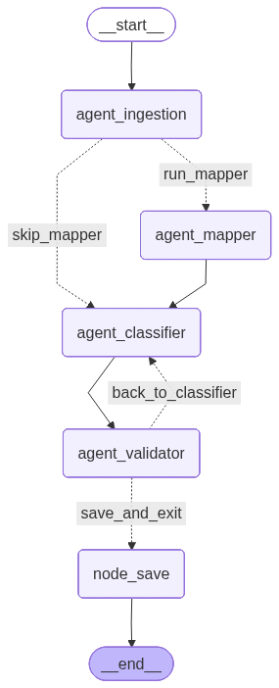
Figure 1: Agents in langgraph
Problems to deal with:
- Complex Tables
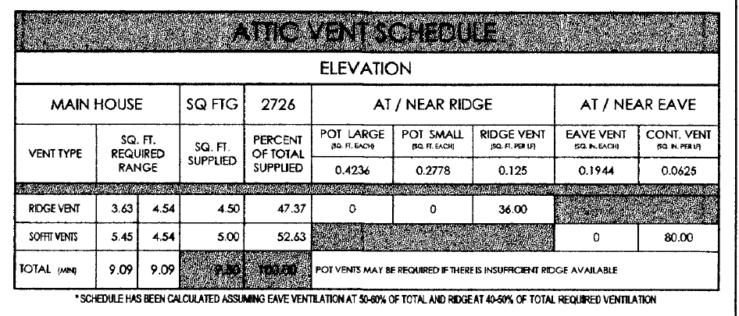
Suggestion by Janesh Sir: Ignore complex table (Solved) ✅

- Notes that aren’t related to pictures
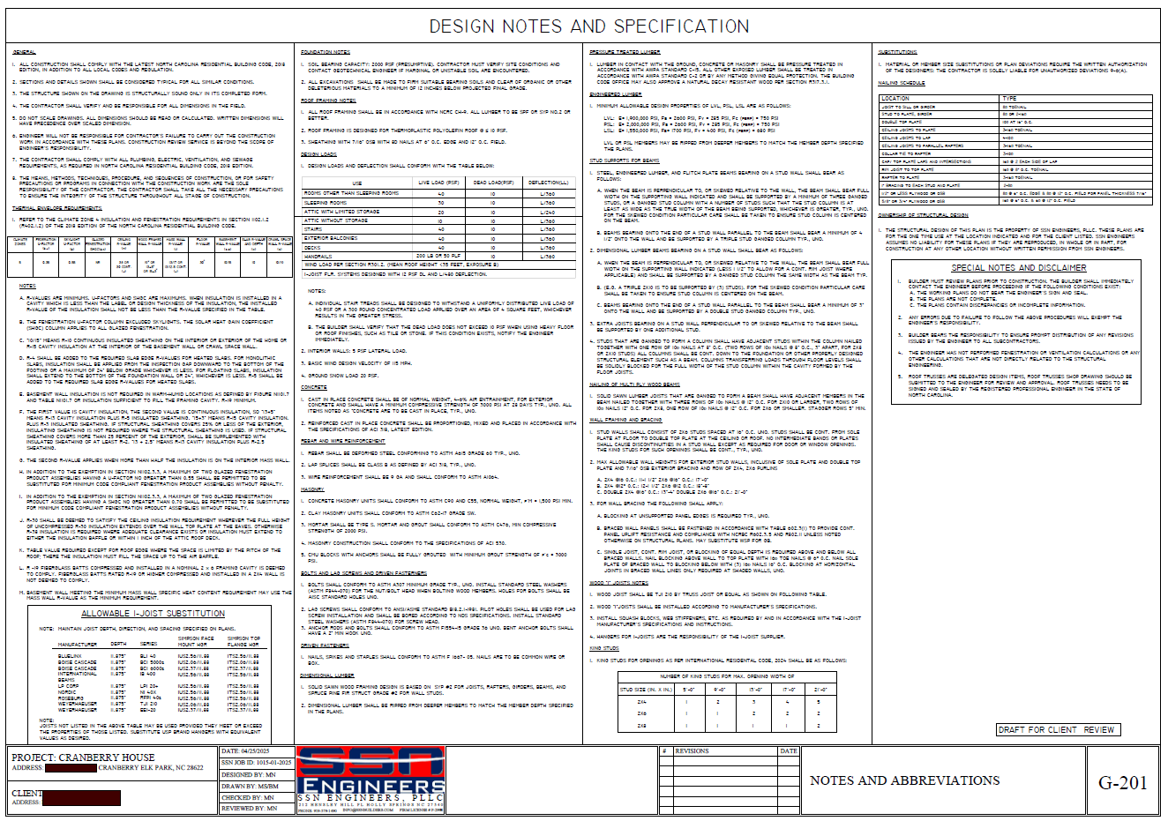
No suggestions
- How do we General Notes?
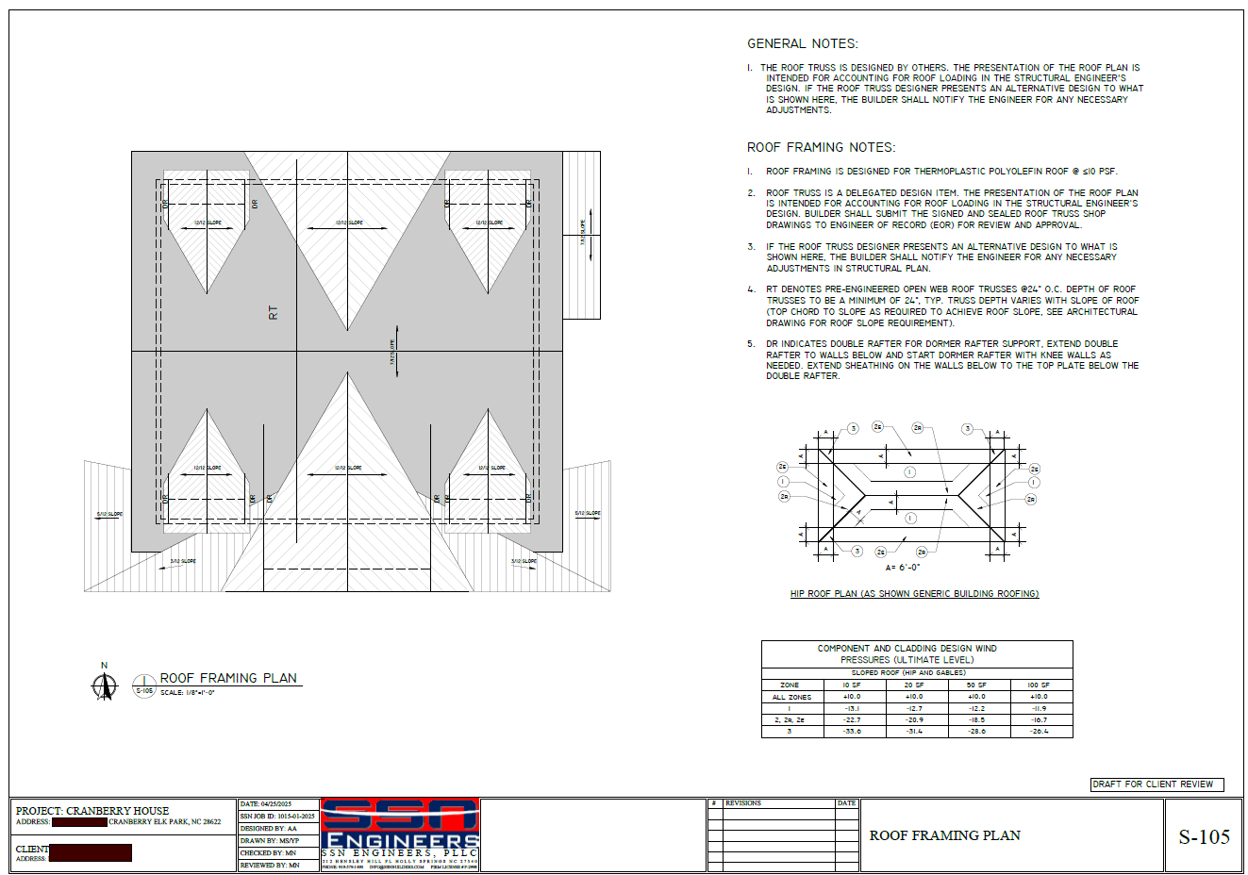
No suggestions

- When Codes are given but the definitions are not.
Final Result JSON:
"W1": {
"notes": "Mapping Required"
},
"W2": {
"notes": "Mapping Required"
},
"W3": {
"notes": "Mapping Required"
},
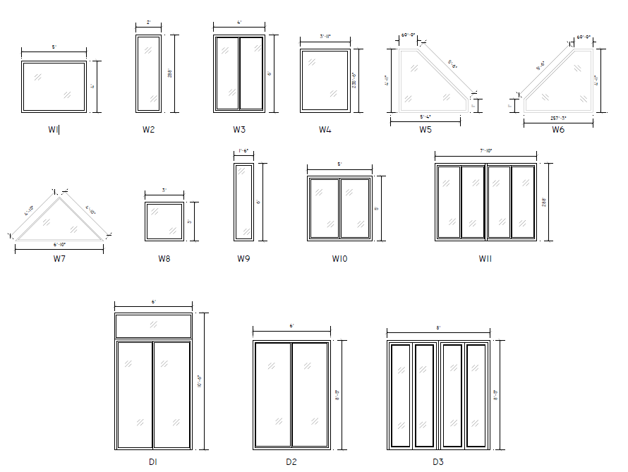
Suggestion by Madan Sir: This is the schedule, maybe add dimensions to the JSON as properties?
Date: May 20, 2026
Problem:
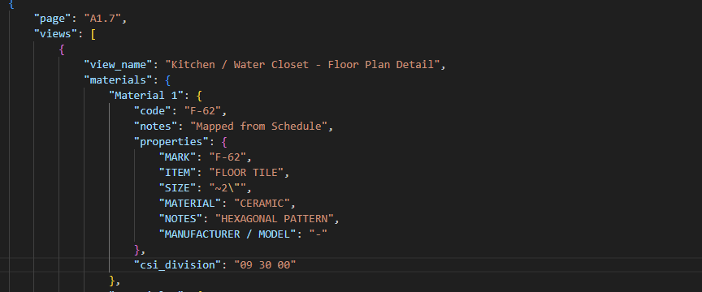
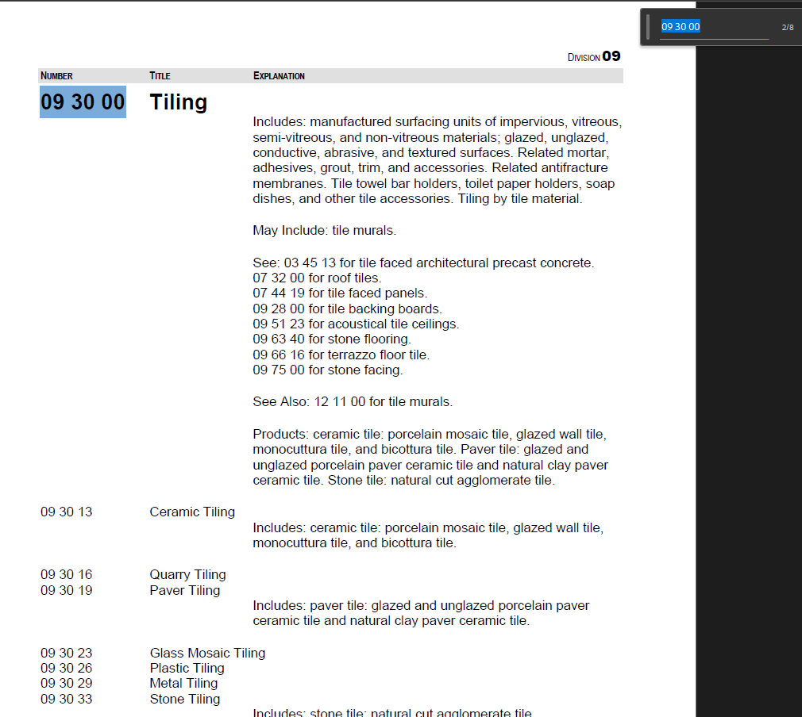

The CSI Division for Ceramic Tile specifically is 09 30 13 (subdivision of 09 30 00) but only the main division is provided, not the sub division.
Solved✅

Date: May 22, 2026
Used Claude API key for result.
- $0.48- $0.7 for 1 run (using sonnet 4.6) 8 page user plan
- Time: 12 mins

Date: May 24, 2026
Solution: Batch Processing
For 8 pages
  - 0.26
  - Time: 3 mins
- For 19 pages: )but in this case, last page schedules were not generated properly so output was wrong)
  - Time: 11 mins
  - Cost: $0.68
Solved✅

Date: May 25, 2026
Problem: Claude’s API can only handle upto 5MB image size due to it’s context window. (200k tokens)
Solution for now: Reduce the file size, save it in jpeg format (lossy compression) -> Images may not be clear for extracting detailed information from the user plan. Solved✅ (temporarily)
For future: Gemini has a large context window (1M tokens) so maybe use Gemini API key. It is also cheaper.
Update: We are using PNG now. (June 8, 2026)

Date: May 27, 2026 (Demo Day)

Ingestion Agent: Calls LLM to extract materials and their related notes. Result: JSON file
Mapper Agent: Maps the codes (X-02, F-23, etc) and provides mapped JSON data. If no codes are available, skip agent
CSI Classifier Agent: Takes the mapped JSON, gets context from the vector database and provides CSI codes for listed materials.
Agent Validator: Checks if the process is ran correctly.
Save JSON
Total: 3 JSON files
Note: Pictures are saved in png for demo.

Added Summary Agent Provides summary of the user plan in .txt file
- Most cost, more time
- One more LLM API call
- For 7 pages, cost = +$0.3, time= +3 mins

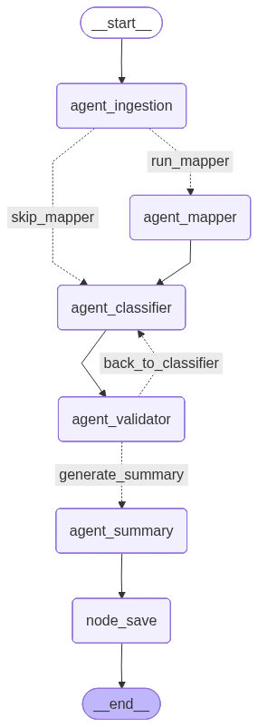
Date: May 28, 2026
Reduced the summary to 2 paragraphs for each page.
Date: June 2, 2026
Time for 19 pages: Upto classification 6.5 min, total(summary included): 15.15 mins
Cost: $ 1.52
Date: June 4, 2026
For calculating accuracy of number of materials detected:
How to calculate total detected (TD):
JSON file read Pass to LLM Count “Materials” Result

How to calculate actual number of materials(A):
Step 1: LLM: Pass the user plan to LLM to count the number of materials in each view (if 2 views are present in a same page and same materials are used for both the views, count it 2 times)
Step 2: Manual count: Manually count the number of materials in the user plan
Step 3: Find the total average of Step 1 and Step 2.

Calculate accuracy:
TD/A * 100%

Calculate Cost:
Claude: Claude Console Credits: Spent money
Gemini: Google AI Studio Dashboard Billing/Usuage/Spend

Claude API Key
Baseline
American Farmhouse
Total Detected CIVIL Materials (TD): 173
Actual Total Materials (A): 205
Accuracy: TD/A * 100 = ~ 84%

CR7 House Plan
Total Detected CIVIL Materials (TD): 68
Actual Total Materials (A): 72
Accuracy: TD/A * 100 = 68/72 * 100 = ~93%

DB
Total Detected CIVIL Materials (TD): 50
Actual Total Materials (A): 54
Accuracy: TD/A * 100 = 50/54 * 100 = ~ 92

Required
Total Detected CIVIL Materials (TD): 25
Actual Total Materials(A): 71
Accuracy: TD/A * 100 = 25/71 * 100 = ~ 36%

Average: ~ 76%

Date: June 5, 2026
Made new branch: geimi_key
Date: June 7, 2026
Problems Faced using Gemini:
- No sync to track cost. Delay: about 10 hours
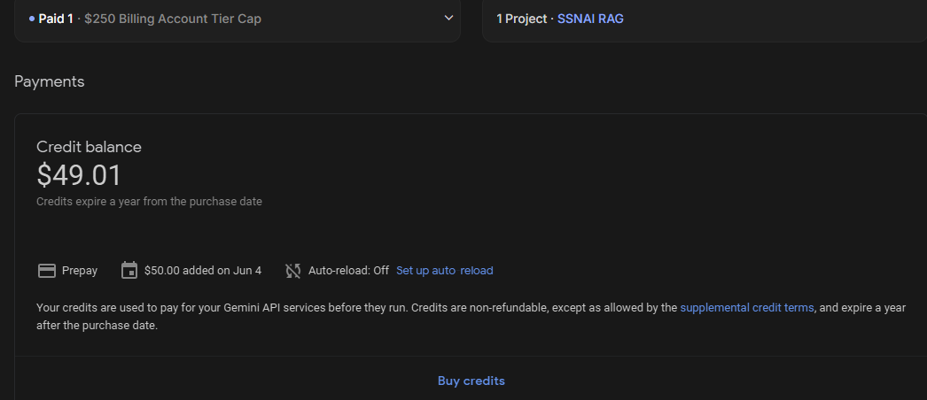
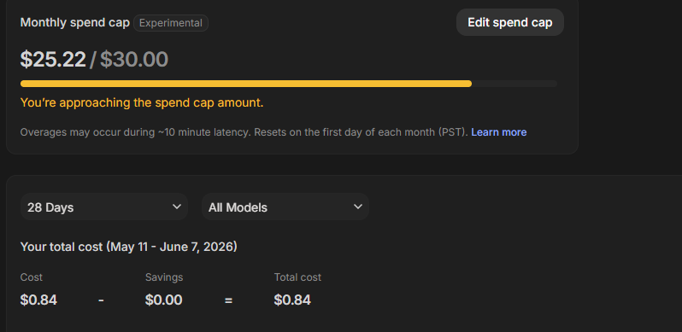

- Gemini PRO models are reasoning / thinking models which is why cost would rise up.
- Gemini doesn’t allow caching whereas Claude allows it which is why for testing, the Claude was far cheaper.

More research to do on:
- Caching Gemini
- Gemini Flash models
- Comparing the 2 AI models and their performances

Date: June 8, 2026
Research on Gemini Model
- Implicit caching (done by model itself) -> no charge but explicit caching for 15 mins in the server takes $0.03 per 1M tokens, for storage, around $1 so total cost for caching prompts 1 hour is $1.03 per 1M tokens.
- Gemini 3.1 pro is reasoning model, trained on Neural Networks which is the best model for images in 2026, but it is a reasoning model so the cost will also include the thinking tokens which might be high for us (If your plan is of 32-70 pages, it will take x32-70 times more)
- Pro models goes into “thinking loop” by analyzing our prompt and image together. Cross validating it so it may take large sum of money.
- Best use- Flash models for images (if we choose Gemini)

Caching prompts in Gemini
- Is it good in our case? Yes. For testing, only 6-7 pages of pdf are used so explicit caching could be tried. For production, it is important as the actual user plan may contain 70 pages.
- Try without caching and try with caching for 6-7 page and find the difference.

Result: Caching in 6-7 page user plan didn’t not have much improvement in the cost. Maybe the 70 page user plan would reduce the cost.

Suggestion: Stick to Claude, use gemini key only for vector embeddings.

Date: June 9, 2026
Fixed Category: Completed✅
Categories: Doors, Windows, Interior Wall, Exterior Wall, Roof, Room, Others
Plan: (D&W, Room, Wall, Roof, Others)
"Material 2": {
"code": "R2",
"notes": "PORCH ROOF ASSEMBLY: ASPHALT SHINGLES, ICE AND WEATHER SHIELD, 5/8\" PLYWOOD C/W H CLIPS AT JOINS, ENGINEERED TRUSSES @ 24 O.C. PER LAYOUT, PAINTED EXTERIOR GRADE MDF SHEATHING, VENTING PER ABC",
"category": "Roof",
"csi_division": "07 31 13"
},
"Material 3": {
"code": "W1",
"notes": "TYPICAL EXTERIOR WALL ASSEMBLY: VINYL SIDING, TYVEK HOUSE WRAP, 3/8\" OSB EXTERIOR SHEATHING, 2X6 STUDS @ 16\" O.C., R-25 BATT INSULATION, 6 MIL POLY VAPOUR BARRIER, 1/2\" GYPSUM DRYWALL",
"category": "Exterior Wall",
"csi_division": "07 46 33"
},

Problem:
- Code repetition:
"Material 7":{
"code": "3",
"notes": "Mapping Required",
"category": "Others",
"csi_division": "00 00 00" },

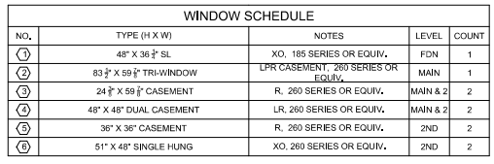

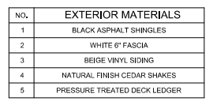

- Spelling mismatch in Master Format and User Plan
User Plan: Facia
Master Format: Faciae

Date: June 10, 2026
- Vector Embedding using Gemini API -> correct csi division
- Added sub-materials along with their CSI division
  - Previous Output:
"Material 12":{
"code": "W1",
"notes": "TYPICAL EXTERIOR WALL ASSEMBLY; VINYL SIDING, TYVEK HOUSE WRAP, 1/2\" OSB EXTERIOR SHEATHING, 2X6 STUDS @ 16\" O.C., R-25 BATT INSULATION, 6 MIL POLY VAPOUR BARRIER, 1/2\" GYPSUM DRYWALL, EFFECTIVE RSI 3.72*",
"category": "Exterior Wall",
"csi_division": "07 46 33"
},

Date: June 11. 2026

Proposed New JSON structure:
{
"extraction_id":"ext-7864325eh72j",
"name":"Black Asphalt Shingles",
"notes":"Roof covering material",
"category":"Roof",
"csi_division":"07 31 13",
"mentions":[
{"page_no": 1, "page_label": "Sheet 4 of 23 - East Elevation (Front)", "view": "East Elevation (Front) - Exterior Elevation View"},
{"page_no": 1, "page_label": "Sheet 4 of 23 - East Elevation (Front)", "view": "Schedules"},
{"page_no": 2, "page_label": "Sheet 5 of 23 - West Elevation", "view": "West Elevation"},
{"page_no": 2, "page_label": "Sheet 5 of 23 - West Elevation", "view": "Exterior Materials Schedule"},
{"page_no": 3, "page_label": "Sheet 6 of 23", "view": "North Elevation - Right Side"},
{"page_no": 4, "page_label": "Sheet 7 of 23 - South Elevation Left Side", "view": "South Elevation"}
]
}

Date: June 14, 2026
- Result in required format
- Extraction id calculation:
Step 1: Take the “name” key and remove the white space in between if any.
Step 2: Convert the name to lowercase
Step 3: Calculate the hast value of the name using hash function
Step 4: Add the prefix: “ext-“
Date: June 16, 2026
- Complete new JSON format for listing the materials: Even if the ‘category’ or ‘notes’ is different then mark it as another material
- Removed blueprint mapper agent from the workflow
Problem:
{
"name": "Wood Steps and Railings",
"notes": "Wood Steps with the railings in entry porch areas",
"category": "Room- Porch",
"mentions": [
{
"page_label": "Sheet 4 of 23 - East Elevation (Front)",
"view": "East Elevation (Front) - Exterior Elevation View"
}
],
“csi_division”: “06 20 00” 06 20 00 Finish Carpentry Includes: finish wood construction
},
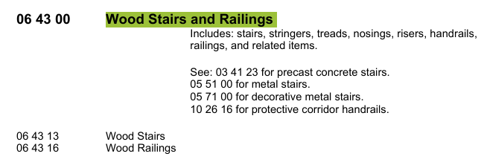
How materials are listed:
- Same name, same notes, same category -> Single material
- Same name, different notes, same category -> Different material
- Same name, same notes, different category -> Different material
- Same name, different notes, different category -> Different material
Problem:

{
"name": "Loose Fill Blown Insulation",
"notes": "R-50 minimum, 5\" cavity, material listed in W2 - Double Wall Assembly at Pony Wall",
"category": "Exterior Wall",
"mentions": [
{
"page_label": "Sheet 17 of 23 - General Notes & Construction Assemblies",
"view": "Construction Assembly Notes - Wall Types",
"Extracted from code": "W2"
}
],
"csi_division": "07 21 00"
},

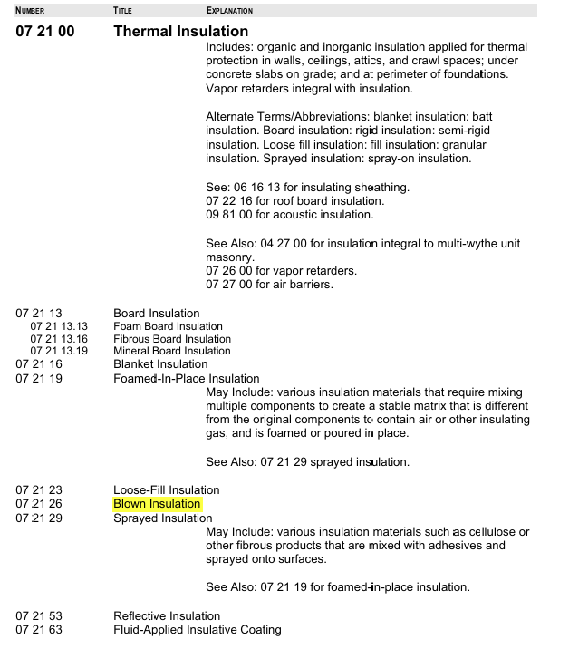

Date: June 18, 2026
- Categories: "Interior Wall", "Exterior Wall", "Door", "Window", "Roof", "Room- RoomName", "Room- Typical", "Foundation-Wall", " Foundation-Room" or "Others"
- Category must be read using notes as well as drawings.
- Batch processing for ingestion agent, schedules passes in each batch.
- Total cost: $0.45 (for 7 page pdf without summary) Time: 1.5 mins-2mins in average
Workflow:
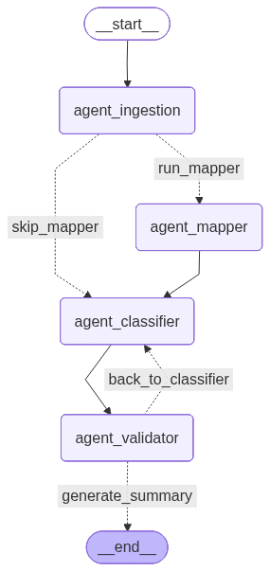
Date: June 21, 2026
Issue: Retrieved chunks are not sent as context properly to the LLM. Solved✅
Checked results in multiple pdfs. ✅
(Revised2.pdf, REQUIRED.pdf, CR-547.pdf)

Pdf :
csi division for 44 materials out of 64 materials ~ 73% (20 not given)
csi division for 59 materials out of 84 materials ~ 70% (25 not given)
csi division for 92 materials out of 109 materials ~ 84% (17 not given)
Average: ~ 75.3%

CSV:
csi division for 59 out of 61 materials ~ 98% (2 not given)
csi division for 78 out of 82 materials ~ 95% (4 not given)
csi division for 24 out of 25 materials ~ 96% (1 not given)
Average: ~ 97%

Date: June 22-25, 2026
- Categories loop:
"category":{
"c1": "Room- Living Room",
"c2": "Room- Bathroom"
},

Eg:
{
"name": "F-60",
"notes": "HARDWOOD FLOOR, 2-3 INCH WIDE, FINISH WOOD, TONGUE & GROOVE, STAINED",
"category": {
"c1": "Room- Living Room",
"c2": "Room- Kitchen",
"c3": "Room- Dining",
"c4": "Room- Main Bedroom",
"c5": "Room- Bedroom",
"c6": "Room- Stair Hall"
},
"mentions": [
{
"page_label": "Sheet A1.7 - Detail Plans",
"view": "Kitchen / Water Closet - Floor Plan Detail"
},
{
"page_label": "Sheet A1.7 - Detail Plans",
"view": "Winder Stairs - Plan Detail"
},
{
"page_label": "Sheet A5.0 - Schedules",
"view": "Materials Schedule"
}
],
"csi_division": "09 64 00"
},

- Parent code -> X "csi_division": "12 35 30.23" also allowed
- Setup for backend : Need of config file ✅
- Updated the repo structure and tested on long pdf files

- In vector database, if “Gypsum Board” occurs 12 times, search one time only -> cost reduction and harmonizing the csi divisions (max number of csi codes gets chosen if multiple csi divisions for same material is shown) Solved✅

- Node Streaming in API -> Anthropic python sdk: default has a built in safety cutoff that blocks non streaming responses if tokens> 20000. If high resolution images were sent then the time would be more so claude blocks it even before processing it. Now, it bypasses that. Now, we shift API node to “stream” mode where networks divides the task into fragments and combines the final JSON data. Solved✅

6 paqe pdf:
Time: 2 mins
Cost: $0.3 - $0.45

25 page pdf:
Time: 9 mins
Cost: $0.95

Date: June 29, 2026
- The subcategories inside category is now mentioned as much times as the number of sub-categories.
- Removed the duplicate: if same name, category and csi division, then remove the duplicates, allow only one.
- If hardware acceleration is possible, use it for reranking.
- Thread optimization: Configured Pytorch to restrict thread pooling.

Date: July 1/2 2026
- Duplication Logic repaired, consider “notes” to indicate duplicate
- Extract “scale” for Floorplans and Elevations in a separate JSON
[
{
"page_label": "A1.2",
"view": "1ST FLOOR PLAN",
"view_type": "FloorPlan",
"scale": "1/4\" = 1'-0\""
},
{
"page_label": "A1.3",
"view": "2ND FLOOR PLAN",
"view_type": "FloorPlan",
"scale": "1/4\" = 1'-0\""
},
{
"page_label": "A2.2",
"view": "BACK ELEVATION (NORTH)",
"view_type": "Elevation",
"scale": "1/4\" = 1'-0\""
}
]
Problem: Back to previous problem -> Claude has less context window so the pdf with heavy png pages will not be processed, and the entire system gets terminated. If we use jpg, the accuracy might be hampered.
Solution: Claude accepts the image size upto 8000 x 8000 so scale down the images if the size limit exceeds. It may hamper the accuracy but the entire process does not get terminated. Solved✅

Date: July 3-7, 2026
- Doors and Windows have specific names as per their schedule.
- The png from pdf is reduced to size 8000 x 8000 if the size limit exceeds.
- Doors and Windows specific category
- Re-ranker also to run in GPU now.
(7-page pdf)
Previous re-rank time: 140 secs Previous I/O time: 80 secs
Current re-rank timer: 22 sec Current I/O time: 2 secs

Problem: If PCs or devices with GPU or mps, the re-rankers work properly. But in production environment, what do we do?
Solution: Use cloud re-rankers
Read paper on re-rankers
OCR for table detevtion -> failed ❌ for complex tables

